Project Design Phase-II
Technology Stack (Architecture & Stack)

Date | 27 June 2025
Team ID | LTVIP2025TMID31924
Project Name | HealthAI: Intelligent Healthcare Assistant Using IBM Granite
Maximum Marks | 4 Marks

Technical Architecture:
The Deliverable shall include the architectural diagram as below and the information as per the table1 & table 2
Example: Order processing during pandemics for offline mode
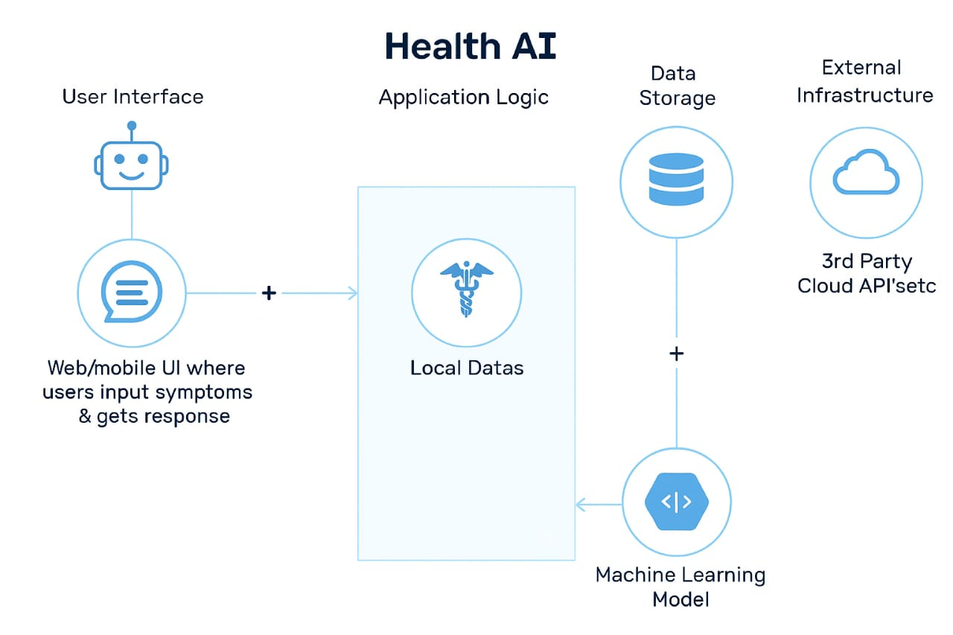
Table-1 : Components & Technologies:
S.No | Component | Description | Technology
 | User Interface | Web/mobile UI where users input symptoms & get responses | HTML, CSS, ReactJS / Android, iOS, Chatbot (Dialogflow)
 | Application Logic-1 | Handles symptom input and user interaction | Java / Python
 | Application Logic-2 | Natural language processing of input | IBM Watson NLU / Google Dialogflow
 | Application Logic-3 | AI decision logic and risk prioritization | Python (Flask/Django), TensorFlow, Scikit-learn
 | Database | Stores patient data, medical records | MySQL / MongoDB
 | Cloud Database | Cloud storage for scale | IBM Cloudant / AWS RDS / Firebase
 | File Storage | Stores images (e.g., scans), reports | AWS S3 / IBM Block Storage
 | External API-1 | Pulls latest medical data / symptoms | WHO API, Healthline API
 | External API-2 | Aadhar or government integration for patient verification | Aadhar API / DigiLocker API
 | Machine Learning Model | Predicts condition based on symptoms and history | Symptom Checker Model (trained using medical datasets)
 | Infrastructure (Server / Cloud) | Deployment setup | IBM Cloud, AWS, Docker, Kubernetes, Local VMs

Table-2: Application Characteristics:
S.NO | Characteristics | Description | Technology
 | Open-Source Frameworks | Use of open-source libraries for ML, backened | TensorFlow, Scikit-learn, Flask
 | Security Implementations | Protects sensitive health data | SHA-256, OAuth 2.0, JWT, IAM, HIPAA Rules
 | Scalable Architecture | Supports thousands of users via microservices and cloud | Kubernetes, Docker, Cloud Foundry
 | Availability | Ensures uptime with distributed systems, load balancers | AWS Load Balancer, CDN, HAProxy
 | Performance | Uses caching and optimized ML inference to ensure low latency | Redis Cache, CDN, TensorRT

